 | 26.14.7 Editors - Properties Editor - Object Data Properties Tab - Grease Pencil Object
Table of content
Detailed table of content 2
Layers panel 5
Layer list 5
Add new layer 5
Add extra menu 6
Remove layer 7
Autolock Inactive layers 7
Ignore Material Locking 7
Blend 7
Opacity 7
Lights 7
Layers panel - Masks subpanel 8
List view 8
Add 8
Subtract 8
Move Up / Down 8
Layers panel - Transform subpanel 8
Layers panel - Adjustment subpanel 9
Tint Color 9
Stroke Thickness 9
Layers panel - Relations subpanel 9
Parent 9
Type 9
Bone 9
Pass Index 9
View Layer 9
Layers panel - Display subpanel 10
Custom Channel Color 10
Show Only On Keyframed 10
Onion Skinning Panel 10
Mode 10
Opacity 11
Filter By Type 11
Keyframes Before/After 11
Custom Colors 11
Display 11
Vertex groups panel 11
Active Vertex Group list 11
Add + 12
Remove - 12
Move Vertex Group Up 12
Move Vertex Group Down 12
Assign 12
Remove 12
Select 12
Deselect 12
Weight 13
Strokes panel 13
Stroke Depth Order 13
Stroke Thickness 13
Thickness Scale 13
Curve Resolution 13
Viewport Display panel 13
Edit Line Color 13
Canvas 14
Custom Properties Panel 14
Add 14
Edit 14
Remove 14

Detailed table of content
Detailed table of content
Detailed table of content 2
Layers panel 5
Layer list 5
Layer name 5
Mask Layer 5
Onion Skinning 5
Viewport/Render Visibility 5
Lock 5
Search Field 5
Add new layer 5
Add extra menu 6
Add Group 6
Grease pencil layers right click menu 6
Delete Group 6
Ungroup 6
Color tags 6
Delete Group 6
Ungroup 6
Duplicate Layer 6
Show All 6
Hide Others 6
Lock All 7
Unlock All 7
Merge Down 7
Merge All 7
Copy Layer to Selected 7
Copy all Layers to Selected 7
Remove layer 7
Autolock Inactive layers 7
Ignore Material Locking 7
Blend 7
Opacity 7
Lights 7
Layers panel - Masks subpanel 8
List view 8
Name of the grease pencil layer 8
Invert 8
Hide 8
Search Field 8
Add 8
Subtract 8
Move Up / Down 8
Layers panel - Transform subpanel 8
Layers panel - Adjustment subpanel 9
Tint Color 9
Factor 9
Stroke Thickness 9
Layers panel - Relations subpanel 9
Parent 9
Type 9
Bone 9
Pass Index 9
View Layer 9
Use Masks in Render 10
Layers panel - Display subpanel 10
Custom Channel Color 10
Show Only On Keyframed 10
Onion Skinning Panel 10
Mode 10
Frames 10
Keyframes 10
Selected 10
Opacity 11
Filter By Type 11
Keyframes Before/After 11
Custom Colors 11
Display 11
Fade 11
Show Start Frame 11
Vertex groups panel 11
Active Vertex Group list 11
Group name 11
Lock 12
Drag Handler 12
Search Field 12
Invert 12
Sort by Name 12
Add + 12
Remove - 12
Move Vertex Group Up 12
Move Vertex Group Down 12
Assign 12
Remove 12
Select 12
Deselect 12
Weight 13
Strokes panel 13
Stroke Depth Order 13
2D Layers 13
3D Location 13
Stroke Thickness 13
World Space 13
Screen Space 13
Thickness Scale 13
Curve Resolution 13
Viewport Display panel 13
Edit Line Color 13
Canvas 14
Color 14
Scale X/Y 14
Offset X/Y 14
Subdivisions 14
Custom Properties Panel 14
Add 14
Edit 14
Remove 14

Layers panel

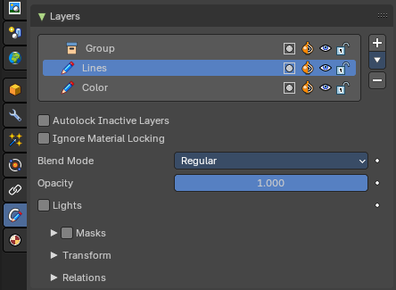
Grease Pencil objects each have a list of 2D layers for grouping and arranging strokes in a List view. Any stroke can only belong to a single 2D layer. There is always only one active layer in the list (the selected one). When you draw, the new strokes are added to the active layer. By default the view order of the layers in the viewport is top to bottom.
Every layer correspond to a channel in the Dope Sheet editor (in Grease Pencil mode). Layers can also be used together with Modifiers to only affects part of your drawing.

Layer list

Layer name
The name of the layer.

Mask Layer
Toggle the Masks visibility in the layer.

Onion Skinning
Toggle the use the layer for Onion Skinning.

Viewport/Render Visibility
Toggle layer visibility in the viewport and in render.

Lock
Toggle layer from being editable.

Search Field
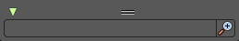
You can expand a search field at the bottom of the list. Type in your term and hit enter to filter for your term.

Add new layer
Adds a new layer.

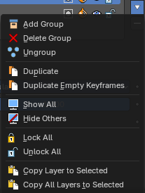
Add extra menu

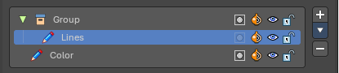
Add Group
Adds a group. You can then drag n drop layers into it.

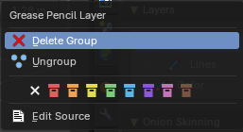
Grease pencil layers right click menu
A right click at a group in the list reveals a menu with further options.

Delete Group
Deletes the selected group.

Ungroup
Ungroups the selected group.

Color tags
Set a color for the selected group.

Delete Group
Deletes the selected group.

Ungroup
Ungroups the selected group.

Duplicate Layer
Makes an exact copy of the selected layer appending a number to differentiate its name.

Show All
Turns on the visibility of every layer in the list.

Hide Others
Turns off the visibility of every layer in the list except the active one.

Lock All
Locks edition of all the layers in the list

Unlock All
Unlocks edition of all the layers in the list.

Merge Down
Merge the selected layer with the layer below. The new layer keeps the name of the lower layer.

Merge All
Merge the selected layer with all layers. The new layer keeps the name of the active layer.

Copy Layer to Selected
Appends the active layer to the selected object.

Copy all Layers to Selected
Appends all layers to the selected object.

Remove layer
Removes the selected layer.

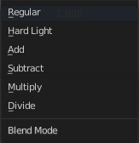
Autolock Inactive layers
Automatically lock all layers except the active one to avoid accidental changes

Ignore Material Locking
Allow editing strokes even if they use locked materials.

Blend
The layer blending operation to perform. See Color Blend Modes.

Opacity
Used to set the opacity of the layer.

Lights
When enabled, the layer is affected by lights.

Layers panel - Masks subpanel

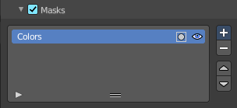
Use another grease pencil layer as a mask.

List view

Name of the grease pencil layer
The name of the layer.

Invert
Invert the mask.

Hide
Set mask layer visible or invisible.

Search Field
You can expand a search field at the bottom of the list. Type in your term and hit enter to filter for your term.

Add
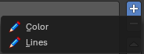
Add a grease pencil layer as a mask layer. The layer must already exist.

Subtract
Remove the grease pencil layer from the list.

Move Up / Down
Move the selected grease pencil mask one up or one down.

Layers panel - Transform subpanel

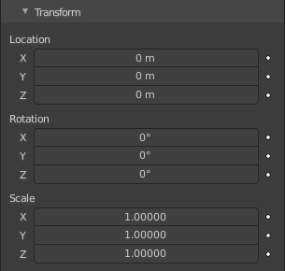
Allows to transform the current grease pencil layer in the 3d view.

Layers panel - Adjustment subpanel
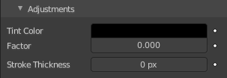

Tint Color
Color that tint any material colors used in the layer.

Factor
The Factor controls the amount of tint color to apply.

Stroke Thickness
Thickness value that override the strokes thickness in the layer.

Layers panel - Relations subpanel

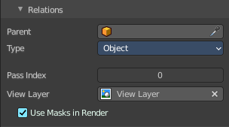
Select a Parent object and Type to manipulate the layer. The layer will inherit the transformations of the parent.
This can be used for rigging for cut-out animation.

Parent
The Parent object.

Type
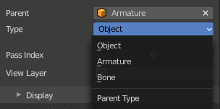
What type of object. When the parent is an armature, then you can choose between object, armature or bone.

Bone
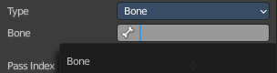
When the type is a bone, then choose which bone of the armature.

Pass Index
The layer index number. It can be used with some modifiers to restrict changes to only certain areas.

View Layer
Defines the View Layer to use for the Grease Pencil layer. If empty, the layer will be included in all View Layers. This is useful to separate drawings parts for compositing.

Use Masks in Render
Include the mask layer when you render the view layer. You need to have a view layer selected to reveal this option.

Layers panel - Display subpanel

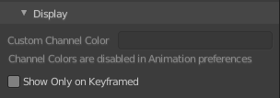
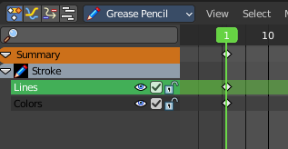
Custom Channel Color
Sets the color to use in the channel region of the Dope Sheet.


Show Only On Keyframed
The layer is just visible in the viewport if it has a keyframe in the actual frame.

Onion Skinning Panel
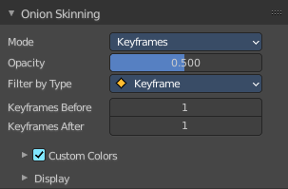
Onion Skinning show ghosts of the keyframes before and after the current frame. This allows animators to judge and pose in between two frames.

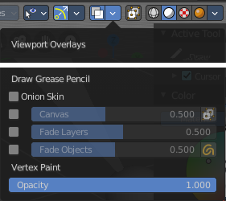

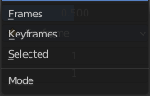
Mode

Frames
Shows Frames in the range determined by the Before/After settings.

Keyframes
Shows Keyframes in the range determined by the Before/After settings.

Selected
Shows only on the manually selected keyframes in the Dope Sheet.

Opacity
Control the opacity of the ghost frames.

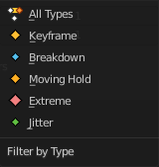
Filter By Type
Filters what type of frames to show in the Onion Skinning range.

Keyframes Before/After
Sets how many frames or keyframes, depending on the Mode, to show before and after the current frame.

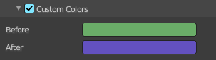
Custom Colors
Before/After
Custom color of the ghost frames before and after the current frame.

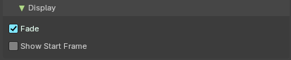
Display

Fade
Opacity of the ghosts frames decrease the further away from the current frame.

Show Start Frame
Display onion keyframes on looping animations.

Vertex groups panel

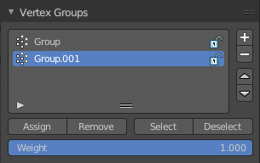
A Vertex group is a group of vertices, a selection of the mesh. It is for example used to weight a specific mesh part to a bone. Or to control the growth of hair particles.
This panel allows you to manage and edit vertex groups. Weight painting creates vertex groups automatically.
In Edit mode this panel shows the inactive controls active.
Vertex groups exists for mesh and lattice objects.

Active Vertex Group list
A List of the vertex groups for this mesh.

Group name
The name of the group. It can be renamed by double clicking at it.

Lock
The lock icon at the end of a group name locks the group from being editable.

Drag Handler
The two vertical lines at the end is a handler with which you can expand the list.

Search Field

You can expand a search field at the bottom of the list. Type in your term and hit enter to filter for your term.

Invert
Exclude the search term instead of searching for it.

Sort by Name
Sort the List by name.

Add +
Create an empty vertex group.

Remove -
Deletes the active vertex group.

Move Vertex Group Up
Moves the selected vertex group up in the list.

Move Vertex Group Down
Moves the selected vertex group down in the list.

Assign
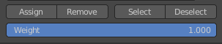
Assign the selected vertices to the active vertex group.

Remove
Remove the selected vertices from the active group.

Select
Select all vertices in the group.

Deselect
Deselect all vertices in the group.

Weight
The weight value that gets assigned to the selected vertices.

Strokes panel
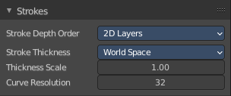

General settings for Grease Pencil strokes.

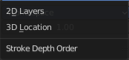
Stroke Depth Order

2D Layers
The Strokes drawing order respect the order of the 2D layers list (top to bottom) and ignores the real position of the strokes in 3D space. See 2D Layers for more information.

3D Location
The strokes drawing order is based on the stroke location in 3D space.

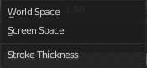
Stroke Thickness

World Space
The thickness is relative to world space. Stroke thickness change with the screen zoom factor.

Screen Space
The thickness is relative to screen space. Stroke thickness remains the same regardless of the screen zoom factor.

Thickness Scale
Sets a thickness scale factor for all strokes.

Curve Resolution
The number of segments generated between two control points when editing strokes in curve edit mode.

Viewport Display panel
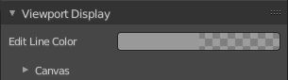

Display settings for Edit Lines in Edit Mode and Sculpt Mode.

Edit Line Color
Sets the color of the Edit Lines.

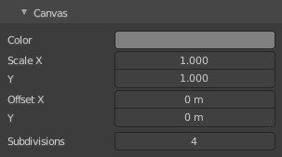
Canvas
In 3D space sometimes is difficult to assess on which plane are you drawing. The Canvas is a display overlay helper that shows a grid at the current Drawing Plane. You can enable the Canvas visualization in the Viewport Overlays.

Color
Color of the Canvas grid lines.

Scale X/Y
Defines the X and Y scale of the Canvas.

Offset X/Y
Sets the Canvas position offset from the object’s origin.

Subdivisions
Specifies the number of subdivisions to use for the grid.

Custom Properties Panel


Here you can define custom properties that can be used for scripting.

Here you might also find custom properties from addons or scripts.

Add
Adds a new property.


Edit
Opens a panel where you can adjust the settings for the custom property.

Remove
Removes the property.

